In this module, we analyzed stock data for the green energy company.

To do this, we used the given stocked data by creating a VBA scrips spreadsheet to collect the value and output from this spreadsheet. We compared two years of stock data. We then refactored the data using the given code in module two and used this to analyze the data performance outcome.

The code/analysis outcome results for 2017 and 2018 were as follows. 2017 number performed better than 2018.

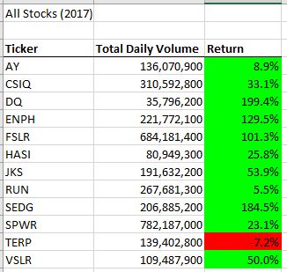

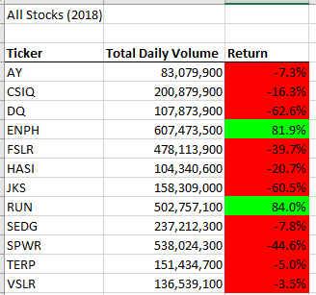

Some of the changes I made to the code were refactoring the code in VBA Macro by looping the rows in the spreadsheet sheet. Refactoring the code made it readable and found mistakes that were hidden.